1 ___________________________

2 ___________________________

3 ___________________________

4 ___________________________

5 ___________________________

|  |  |
| --- | --- |
| **Singular** | **Plural** |
| ¿Cuánto cuesta? | ¿Cuánto cuestan? |
| Cuesta…. | Cuestan…. |

6 ___________________________

7 ___________________________

8 ___________________________

9 ___________________________

10 __________________________

To add these together: (hundreds) (tens) *y* (ones)

Ex: 138 = ciento treinta y ocho

11 __________________________

12 __________________________

13 __________________________

14 __________________________

15 __________________________

16 __________________________

17 __________________________

18 __________________________

19 __________________________

20 __________________________

30 __________________________

40 __________________________

50 __________________________

60 __________________________

70 __________________________

80 __________________________

90 __________________________

100 ________________________

200 ________________________

300 ________________________

400 ________________________

500 ________________________

600 ________________________

700 ________________________

800 ________________________

900 ________________________

1000 _______________________

Money _______________________________________

Price _________________________________________

Dollar(s) ____________________________________

Cent(s) ______________________________________

Cash _________________________________________

Credit card __________________________________

Expensive ___________________________________

Cheap ________________________________________

**Directions:**

You have a **$500**  budget. You may go shopping and buy anything that you want on the linked website in the PowerPoint but you must not go over your budget!

Fill in the name of the object and the price (in Spanish!) on this worksheet to keep track of what you are buying and how much you are spending.

|  |  |
| --- | --- |
| **Object** | **Price** |
| Ex: La camisa | Cuesta diecinueve dólares |
|  |  |
|  |  |
|  |  |
|  |  |
|  |  |
|  |  |
|  |  |
|  |  |
|  |  |
|  |  |
|  |  |
|  |  |
| **TOTAL AMOUNT SPENT:** |  |

Classwork:

1. ¿Cuanto cuesta el vestido? ____________________________________________________
2. ¿Cuánto cuesta la camiseta? ____________________________________________________
3. ¿Cuánto cuestan las camisas? ____________________________________________________
4. ¿Cuánto cuestan los jeans? ____________________________________________________
5. ¿Cuánto cuestan los pantalones? ____________________________________________________
6. ¿Cuánto cuestan los pantalones cortos? ____________________________________________________

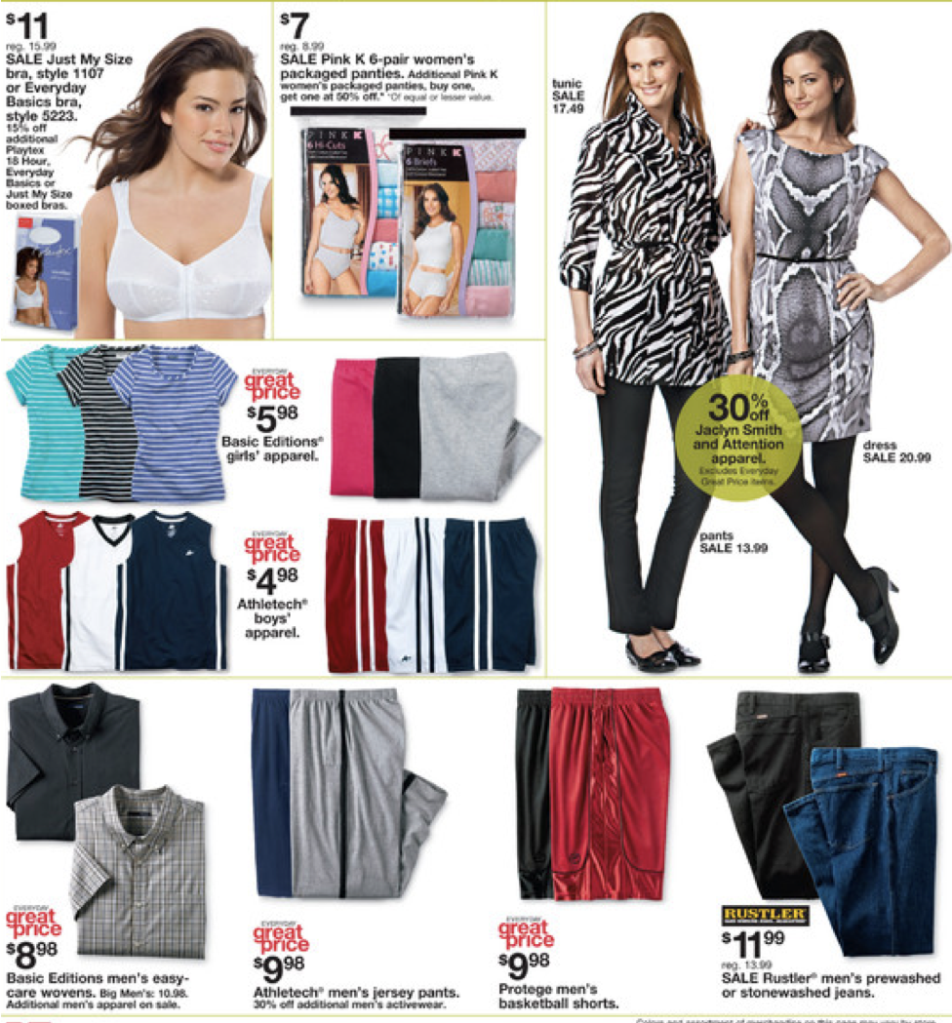

**Directions**:

*Answer the questions below in FULL SPANISH SENTENCES based on the information on the catalogue page.*

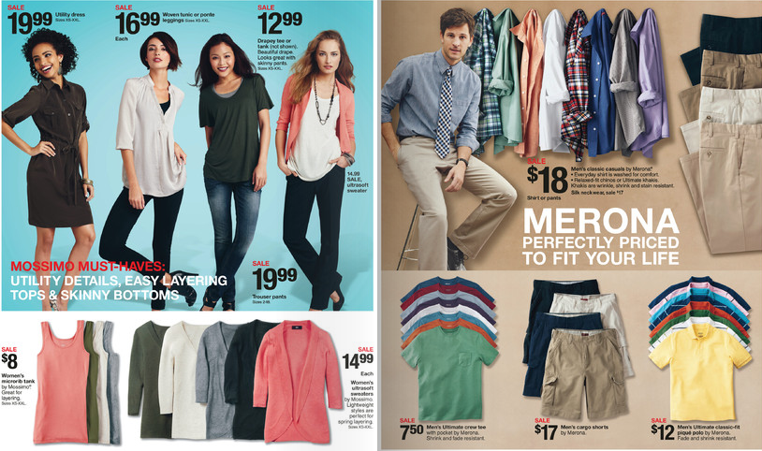

1. ¿Cuánto cuesta la camiseta? ________________________________________________________________
2. ¿Cuánto cuesta el vestido? __________________________________________________________________
3. ¿Cuánto cuestan los pantalones cortos? ___________________________________________________
4. ¿Cuánto cuesta el sueter? ___________________________________________________________________
5. ¿Cuánto cuestan los pantalones? ___________________________________________________________

*Write the following numbers in Spanish:*

243 ____________________________________________________________________________________________________

725 ____________________________________________________________________________________________________

368 ____________________________________________________________________________________________________

112 ____________________________________________________________________________________________________

937 ____________________________________________________________________________________________________

2,011 __________________________________________________________________________________________________

4,540 __________________________________________________________________________________________________

9,871 __________________________________________________________________________________________________

1,514 __________________________________________________________________________________________________

**Tarea**:

*Translate the following sentences:*

1. The shirt costs $87.  
   _____________________________________________________________________________________________________
2. My pants cost $140.   
   _____________________________________________________________________________________________________
3. His hat costs $12.33.  
   _____________________________________________________________________________________________________
4. Your red jacket costs $95.  
   _____________________________________________________________________________________________________
5. Do you like my jeans?  
   _____________________________________________________________________________________________________
6. Our shoes cost $200.  
   _____________________________________________________________________________________________________
7. The boots cost $95.  
   _____________________________________________________________________________________________________
8. The yellow jacket costs $87.  
   _____________________________________________________________________________________________________
9. My t-shirt is more expensive than your t-shirt.  
   _____________________________________________________________________________________________________
10. I don’t have money!  
    _____________________________________________________________________________________________________
11. I want to buy the pants with cash.  
    _____________________________________________________________________________________________________
12. Your dress is cheap!  
    _____________________________________________________________________________________________________
13. What does your tie cost?  
    _____________________________________________________________________________________________________